Hello there, fellow programmers. Chances are if you are here you are having trouble installing MySQL and MySQLClient on your Mac System. In this documentation I am going to illustrate step by step on how to connect and install MySQL and MySQLClient library on your MacOS. Here is the step by step explanation:

**Step One: Install Brew**

You need **Homebrew** on your local system to install MySQL easily. You can use the following command to install it.

***/usr/bin/ruby -e "$(curl -fsSL https://raw.githubusercontent.com/Homebrew/install/master/install)"***

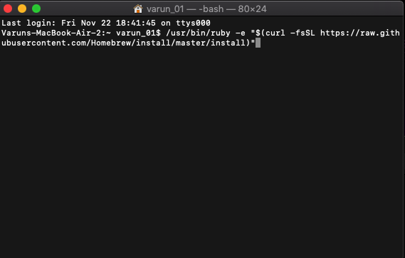

**Step Two:**

1. **Install MySQL using brew**

Use the following command to install MySQL:

***brew install mysql***

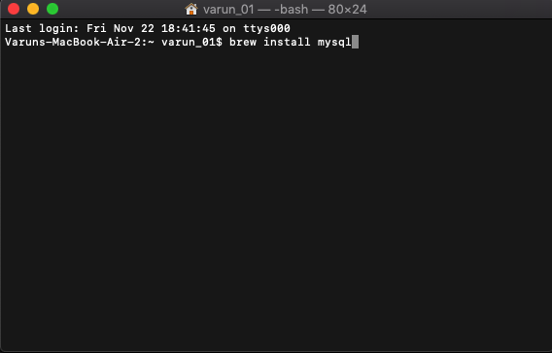

1. **Setup MySQL credentials**

Use the following command to setup MySQL credentials.

***mysql_secure_installation***

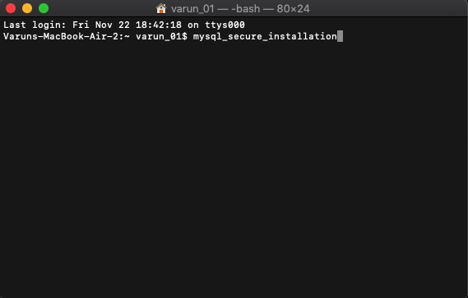

**Step Three: Install MySQL-Connector-C**

You need to install this connector to connect to any other application to MySQL. There’s a chance it will ask you to unlink MySQL before installing the connector. Use the following commands:

***brew unlink mysql (to unlink mysql)***

***brew install mysql-connector-c (to install connector)***

Then according to mysqlclient’s documentation you need to put the following bug fix in the mysql_config file usually located at “/usr/local/bin/mysql_config”. For that open finder and press “Command+Shift+G” and then type “usr” and navigate to the “mysql_config” file. Right Click the file and choose the “Show Orignal” and it will redirect you to a exec file. Open the file with textedit or any other text editor you prefer and change the following lines of code (found on about line 112).

**Change:**

**libs=“-L$pkglibdir”**

**libs=”$libs -l”**

**To:**

libs=“-L$pkglibdir”

libs=“$libs –lmysqlclient –lssl -lcrypto”

**Step Four: Install XCode-Select**

You can do this by:

***xcode-se;ect-install***

**Step Five: Install OpenSSL**

For the commands you edited in step three you have to have a path for OpenSSL lib. To install OpenSSL use this command.

***brew install openssl***

Then export the path to environment using the following:

***Esport LIBRARY_PATH=$LIBRARY_PATH:/usr/local/opt/openssl/lib/***

**Step Six: Link “mysql-connector-c”**

The connector you installed in step three should be connected by default but run the following command to be sure. Run the “brew unlink mysql” command if the connector is not connected by default.

***brew link –overwrite mysql-connector-c***

**Step Seven: Install MySQLClient**

Now you should be able to install mysqlclient without any errors. Run the following command:

***pip install mysqlclient***

**Step Eight: Link MySQL back again**

Do the opposite of step six and unlink mysql-connector-c and link mysql back again.

***brew unlink mysql-connector-c***

***brew link –overwrite mysql***

Hopefully now you should be able to connect to mysql from your python application.